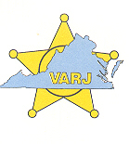
November 14, 2018

Dear Vendor,

Thank you for being a part of the Virginia Association of Regional Jails (VARJ) 20th Annual Training Conference. We greatly appreciate your time and participation.

Enclosed you will find a vendor information packet which details booth dimensions as well as information regarding electrical, move-in date and times, exhibit hours, and freight handling.

If you have any questions, please contact Marissa Dickens at (757) 942-0527 or via email at dickensm@wtrj.org for further information.

Sincerely,

William C. Smith

William C. Smith
Superintendent
President
Virginia Association of Regional Jails

